Asia-China-Coin-Knife Money-Type 1, Qi Knives-400-220 BCE.

There is no problem in equating theKnife Money with the actual knives in use during the Zhou period. They appear to have evolved in parallel with the Spade money in the north-east of China.

Type1.齊(卉)刀Qi Knives.

These large knives are attributed to the State of Qi， and are found in the Shandong area. They do not appear to have circulated much outside of this area.Although there has been consider­able controversy concerning the date of their issue， archaeology shows them to be products of the Warring States period. They are known as Three CharacterKnives， Four Character Knives and so on， according to the number of characters in their inscriptions. Some consider the three horizontal lines and the mark below on some reverses are part of the inscription

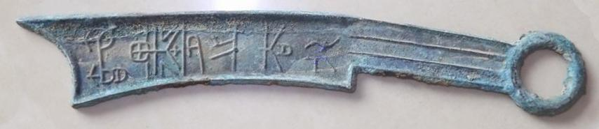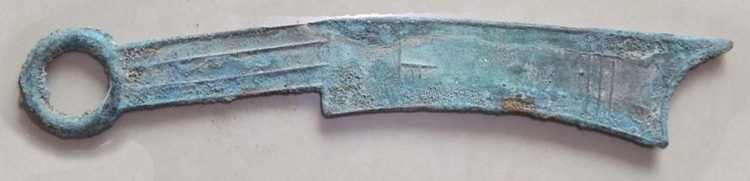

Knives (400-220 BC). Harthill 4.2 Obv:節(即)壘之法化*Ji Mo Zhi*Feα*Hu*α(Jimo'自Legal Money). Rev:闢(辟)封*Pi Feng.*

